3. Synthesis:
Biodegradable polymers can be synthesized in different ways.
3.1 Synthesis from natural Polymers:
Natural polymers can be upgraded to customize properties, degradation rates for making suitable in different application areas.Biopolymers, mainly polysaccharide polymeric materials like cellulose, starch, chitin, and chitosancan be modified into new biodegradable polymer materials by Graft copolymerization, coblending and functional group insertion[1, 2]. For example, by Graft copolymerization the chelating, complexation and antibacterial properties can be improved [3].

3.2 Chemical synthesis:

Biodegradable polymers can be synthesized artificially to mimic the structure of natural polymers particularly containing chains of amide, ester, and peptide which are readily biodegradable.Ring-opening polymerization (ROP) is regarded as one of the most versatile and flexible methods for large-scale production of major groups of biopolymers. As for example Polylactic Acid (PLA) is fabricated through directpolycondensation of lactic acid (step growth) or the chain growth ROPof its cyclic dimer lactideusingcatalysts generally Stannous OctoateSn(Oct)2[4]. The PLA synthesis shown in Fig. 1.

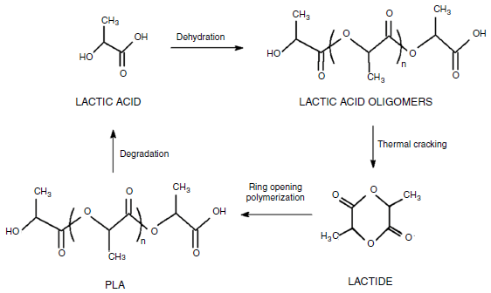

Fig. 1 PLA synthesis route [5]

High-molecular-weight Poly (L-Lactide-co-glycolide) PLGA is synthesized by the ROP of lactide and glycolidewhich are cyclic diesters of lactic acid and glycolic acid, respectively, with Sn(Oct)₂ catalyst (shown in Fig. 2) [1, 6, 7].

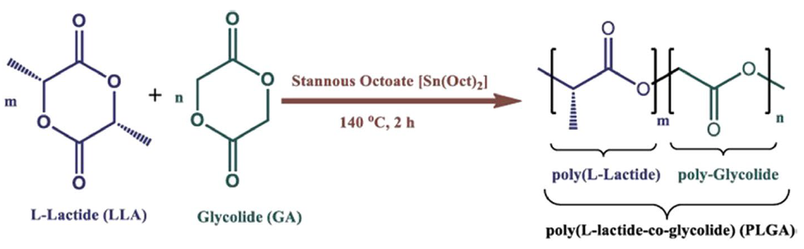

Fig. 2Synthesis of poly(lactide-co-glycolide) by using ROP process (m = number of lactide units, and n = number of glycolide units) [7]

3.3 Enzymatic and Chemoenzymatic Synthesis:
Various biodegradable polymers like polyamide, polysaccharide, and polyester can be produced through enzyme-mediated synthesis. Enzymes can reduce processing charge as they can work at room temperature and atmospheric pressure. Also enzymes can be recycled [8]. Cheng et al. [9] described the bulk lipase-catalyzed polymerization (LCP) where aliphatic polyamides produced from diamines and diesters [shown in Fig. 3].
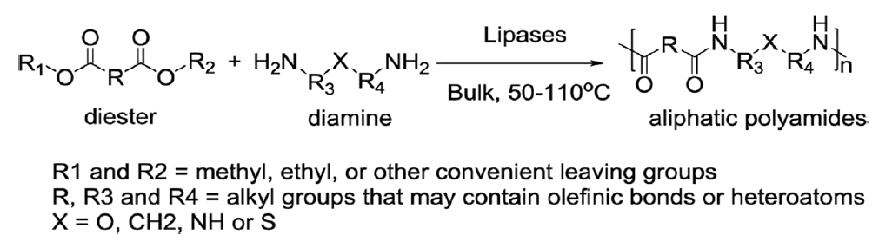
Fig. 3 LCP for aliphatic polyamides [1, 9]

Chemoenzymatic Synthesis is combination of traditional polymerization and highly efficient enzymatic strategy. this method illustrates both higher stereoselectivity and economic efficiency in comparison with chemical and enzymatic processes [10]. Cai et al. [11] used an efficient chemoenzymatic method for synthesis of some optically active polymeric prodrugs for nonsteroidal anti-inflammatory drugs with high molecular weight.

3.4 Microbiological Synthesis:

Considering sustainable development, the microbes are being used to produce biopolymers having excellent properties like biodegradability, biocompatibility, and structural diversity. A variety of biocompatible polymers can be synthesized by microorganisms like poly (hydroxyalkanoates) (PHAs), poly (hydroxybutyrate) (PHB) poly (hydroxybutyrate-hydroxyvalerate) (PHBV) etc.

Polyhydroxyalkanoates (PHAs) is one of the biodegradable microbial polyesters to have potential to replace traditional petrochemical-derived plastics in a circular economy [12].Recently, PHAs are attracting more attention because of its wide variety of applications based on the diverse properties of PHAs family [13].PHAcan be synthesized by microorganisms from different carbon sources ofcarbohydrates, n-alkanes, n-alcohols, n-alkanoic acids, gaseous hydrocarbons like starch, cellulose; hexane, octane;methanol, ethanol; acetic acid, propionic acid; methane and carbon dioxide.But due to the high costs of substrates for PHAs synthesis not become competitive compared to the oil-based plastic market. The pre-treatment techniques like hydrolysis, fermentation, enzymolysis, and pyrolysis required conversion of raw feedstock into food of microbes. This also increase cost [14]. To reduce the costissue, the potential feedstock like the waste materials from industries (e.g. pulp and paper mill), agricultural residues (e.g. sugar cane molasses) and various kinds of wastewater can be reused for the production of PHA which reduce the burden of waste management as well [15, 16].Also the carbon cycle of PHAs production and degradation provides a foundation in a circular economy and solve the issues of plastic pollution [17].A closed-loop of PHAs production from waste feedstock has been shown in Fig. 4.

Fig. 4. A closed-loop of PHAs production from waste feedstock.
Till date more than 150 PHAs have been recognized based on their unique monomer units[18]. PHB is the most common and the first industrially produced homopolymeric PHA. PHBVis the one of the PHAs copolymers [19].In PHAs production the carbon sources are metabolized by enriched cultures or mixed microbial cultures (MMCs) for production of PHAs [20]. MMCs containing a variety of microorganisms are more effective to metabolize complex feedstocks[21] and prospective for large-scale production [22].PHB and PHBV are the major category of PHAs generated from waste streams.PHAs are generally accumulated intracellular as a reserve energy source in the cytoplasm of the PHAs-producing microbes under unbalanced growth conditions or synthesized to resist environmental stress (e.g., high temperature, osmotic shock, and UV radiation) [23].

For efficient PHA production bacterial feeding regimes are very important deciding factor [24]. Single strains necessitate extremely sterilized and intricate operational conditions [25]whereas mixed microbial community (MMCs) may overcome the limitations.But maintaining stability is difficult to produce PHAs with an MMC [26].Generally, a majority of microorganisms have the ability of PHAs storage and PHAs degradation owing to the presence of PHAs synthase (PhaC) and PHAs depolymerase (PhaZ) [27]. Most research focused on PHAs production and how to avoid internal degradation [28]. Preventing enzymatic degradation could provide a new approach to overcome the issue of PHAs degradation in the production process [29].Various PHAs produced based on carbon sources [30] and capability of microbial species [31]. Highly efficient strains like Methanotrophs produce PHA from Methane is single carbon source [32]. Paracoccusdenitrificansand Cupriavidusnecatorcan produce PHAs using CO₂ as single carbon source [33], which help to mitigate climate change in a circular economy [34].

Although there are various environmental challenges in PHAs production, the greatest concern is the instability of the microbial consortia in case of using MMCs. Also MMCs not used in industrial PHAs production [35]. Moreover, the quality of produced PHAs using MMCs is another aspect of investigation when produced from waste streams. Hence, a suitable culturing strategy, optimal growth conditions, and efficient extraction methods are essential for improving PHAs yield in the case of MMCs.

References:

1. Pellis A, Comerford J, Weinberger S, Guebitz G, Clark J, Farmer T (2019) Enzymatic synthesis oflignin derivable pyridine-based polyesters for the substitution of petroleum derived plastics. NatCommun 10(1):1762

2. Gu Q, Maslanka W, Cheng H (2008) Enzyme-catalyzed polyamides and their derivatives. ACS Symposium
Series, pp.309–319.

3. Chao Q, Ding Y, Chen Z, Xiang M, Wang N, Gao X (2020) Recent progress in chemo-enzymaticmethods for the synthesis of N-glycans. Front Chem 8:513

4. Knani D, Gutman A, Kohn D (1993) Enzymatic polyesterification in organic media. Enzyme-catalyzedsynthesis of linear polyesters. I. Condensation polymerization of linear hydroxyesters. II. Ring-openingpolymerization of ε-caprolactone. J PolymSci Part A: PolymChem 31(5):1221–1232

5. Mehta R, Kumar V, Bhunia H, Upadhay SN. Synthesis of poly(lactic acid): a review. J MacromolSci, Phys. 2006. https ://doi.org/10.1080/15321 79050 03041 48.

6. Narancic T, Cerrone F, Beagan N, O’Connor K (2020) Recent advances in bioplastics: applicationand biodegradation. Polymers 12(4):920

7. ASTM D 6400-99, 1976. Standard specification for compostable plastics, annual book of standards.ASTM, Philadelphia

8. Kumar Tiwari A, Gautam M, Maurya H (2018) Recent development of biodegradation techniques ofpolymer. Int J Res 6(6):414–452

9. Liu L, Xu M, Ye Y, Zhang B (2022) On the degradation of (micro)plastics: degradation methods,influencing factors, environmental impacts. Sci Total Environ 806:151312

10. Filiciotto L, Rothenberg G (2020) Biodegradable plastics: standards, policies, and impacts. Chemsuschem14(1):56–72

11. Cai X, Wang N, Lin X (2006) The preparation of polymerizable, optically active non-steroidalanti-inflammatory drugs derivatives by irreversible enzymatic methods. J MolCatal B Enzym40(1–2):51–57

12. Moradali, M.F., Rehm, B.H.A., 2020. Bacterial biopolymers: from pathogenesis to advanced materials. Nat. Rev. Microbiol. 18, 195–210. https://doi.org/10.1038/ s41579-019-0313-3.

13. Nanda, S., Patra, B.R., Patel, R., Bakos, J., Dalai, A.K., 2022. Innovations in applications and prospects of bioplastics and biopolymers: a review. Environ. Chem. Lett. 20, 379–395. https://doi.org/10.1007/s10311-021-01334-4

14. Nielsen, C., Rahman, A., Rehman, A.U., Walsh, M.K., Miller, C.D., 2017. Minireview Food Waste Conversion to Microbial Polyhydroxyalkanoates 0. https://doi.org/10.1111/ 1751-7915.12776.

15. Harrison, T.R., Gupta, V.K., Alam, P., Perriman, A.W., Scarpa, F., Thakur, V.K., 2023. From trash to treasure: sourcing high-value, sustainable cellulosic materials from living bioreactor waste streams. Int. J. Biol. Macromol. 233, 123511 https://doi.org/ 10.1016/j.ijbiomac.2023.123511.

16. De DonnoNovelli, L., Moreno Sayavedra, S., Rene, E.R., 2021. Polyhydroxyalkanoate (PHA) production via resource recovery from industrial waste streams: a review of techniques and perspectives. Bioresour. Technol. 331, 124985 https://doi.org/ 10.1016/j.biortech.2021.124985.

17. Bellini, S., Tommasi, T., Fino, D., 2022. Poly(3-hydroxybutyrate) biosynthesis by Cupriavidusnecator: a review on waste substrates utilization for a circular economy approach. Bioresource Technology Reports 17, 100985. https://doi.org/10.1016/j. biteb.2022.100985.

18. Choi, S.Y., Cho, I.J., Lee, Y., Kim, Y.J., Kim, K.J., Lee, S.Y., 2020. Microbial Polyhydroxyalkanoates and Nonnatural Polyesters. Advanced Materials. https://doi. org/10.1002/adma.201907138.

19. Chen, G.Q., Wu, Q., 2005. The application of polyhydroxyalkanoates as tissue engineering materials. Biomaterials 26, 6565–6578. https://doi.org/10.1016/j. biomaterials.2005.04.036.

20. Kumar, M., Verma, S., Gazara, R.K., Kumar, M., Pandey, A., Verma, P.K., et al., 2018. Genomic and proteomic analysis of lignin degrading and polyhydroxyalkanoate accumulating β-proteobacteriumPandoraea sp. ISTKB. Biotechnology for Biofuels 11, 1–23. https://doi.org/10.1186/s13068-018-1148-2.

21. Montiel-Jarillo, G., Carrera, J., Su´arez-Ojeda, M.E., 2017. Enrichment of a mixed microbial culture for polyhydroxyalkanoates production: effect of pH and N and P concentrations. Sci. Total Environ. 583, 300–307. https://doi.org/10.1016/j. scitotenv.2017.01.069.

22. Wang, K., Hobby, A.M., Chen, Y., Chio, A., Jenkins, B.M., Zhang, R., 2022. Techno-economic analysis on an industrial-scale production system of polyhydroxyalkanoates (PHA) from cheese by-products by halophiles. Processes 10. https://doi.org/10.3390/pr10010017.

23. Obruca, S., Sedlacek, P., Koller, M., Kucera, D., Pernicova, I., 2018. Involvement of polyhydroxyalkanoates in stress resistance of microbial cells: biotechnological consequences and applications. Biotechnol. Adv. 36, 856–870. https://doi.org/ 10.1016/j.biotechadv.2017.12.006.

24. Colpa, D.I., Zhou, W., Wempe, J.P., Tamis, J., Stuart, M.C.A., Krooneman, J., et al., 2020. Thaueraaminoaromatica MZ1T identified as a polyhydroxyalkanoate-producing bacterium within a mixed microbial consortium. Bioengineering 7, 19. https://doi. org/10.3390/bioengineering7010019.

25. Koller, M., Mukherjee, A., 2022. A new wave of industrialization of PHA biopolyesters. Bioengineering 9. https://doi.org/10.3390/bioengineering9020074.

26. Zhou, W., Colpa, D.I., Geurkink, B., Euverink, G.J.W., Krooneman, J., 2022. The impact of carbon to nitrogen ratios and pH on the microbial prevalence and polyhydroxybutyrate production levels using a mixed microbial starter culture. Sci. Total Environ. 811 https://doi.org/10.1016/j.scitotenv.2021.152341.

27. Chen, G.Q., Chen, X.Y., Wu, F.Q., Chen, J.C., 2020. Polyhydroxyalkanoates (PHA) toward cost competitiveness and functionality. Advanced Industrial and Engineering Polymer Research 3, 1–7. https://doi.org/10.1016/j.aiepr.2019.11.001.

28. Ren, Q., De Roo, G., Witholt, B., Zinn, M., Th¨ony-Meyer, L., 2010. Influence of growth stage on activities of polyhydroxyalkanoate (PHA) polymerase and PHA depolymerase in Pseudomonas putida U. BMC Microbiol. 10, 1–9. https://doi.org/ 10.1186/1471-2180-10-254.

29. Hou, Q., Zhen, M., Qian, H., Nie, Y., Bai, X., Xia, T., et al., 2021. Upcycling and catalytic degradation of plastic wastes. Cell Reports Physical Science 2, 100514. https://doi. org/10.1016/j.xcrp.2021.100514.

30. Bhatia, S.K., Otari, S.V., Jeon, J.M., Gurav, R., Choi, Y.K., Bhatia, R.K., et al., 2021. Biowaste-to-bioplastic (polyhydroxyalkanoates): conversion technologies, strategies, challenges, and perspective. Bioresour. Technol. 326, 124733 https://doi.org/ 10.1016/j.biortech.2021.124733.

31. Yadav, B., Talan, A., Tyagi, R.D., Drogui, P., 2021. Concomitant production of value-added products with polyhydroxyalkanoate (PHA) synthesis: a review. Bioresour. Technol. 337 https://doi.org/10.1016/j.biortech.2021.125419.

32. Koller, M., 2020. Advances in Polyhydroxyalkanoate (PHA) Production, ume 2. https:// doi.org/10.3390/bioengineering7010024. Bioengineering.

33. Volova, T.G., Kiselev, E.G., Shishatskaya, E.I., Zhila, N.O., Boyandin, A.N., Syrvacheva, D.A., et al., 2013. Cell growth and accumulation of polyhydroxyalkanoates from CO2 and H2 of a hydrogen-oxidizing bacterium, Cupriaviduseutrophus B-10646. Bioresour. Technol. 146, 215–222. https://doi.org/ 10.1016/j.biortech.2013.07.070.

34. Lee, J., Park, H.J., Moon, M., Lee, J.S., Min, K., 2021. Recent progress and challenges in microbial polyhydroxybutyrate (PHB) production from CO2 as a sustainable feedstock: a state-of-the-art review. Bioresour. Technol. 339, 125616 https://doi. org/10.1016/j.biortech.2021.125616.

35. Sabapathy, P.C., Devaraj, S., Meixner, K., Anburajan, P., Kathirvel, P., Ravikumar, Y., et al., 2020. Recent developments in Polyhydroxyalkanoates (PHAs) production – a review. Bioresour. Technol. 306, 123132 https://doi.org/10.1016/j. biortech.2020.123132.

